Sprite Sheets

As we develop more complex and design-rich pages, the number of images our pages will have will most likely increase. With this increase in images comes an increase in the number of separate requests that a user's browser needs to make to obtain everything it needs to display the page properly. This will start slowing down our page load time, which has a very noticeable effect on mobile devices in particular. This is where sprite sheets can help out.

Sprite sheets are single image files that are composed of multiple images that would normally be used separately in your page design. Having many images combined into one reduces the number of HTTP requests the browser needs to make, speeding up page load times. Sprite sheets can be created in a variety of different ways, but the method most commonly used is by lining all of the images up either side by side in a horizontal image or on top of each other in a vertical image.

Let's use a battery indicator icon for our example. We are given four separate images for each state of the battery indicator. We could use them each individually, but that presents two potential problems. The first we've already covered. More images means more requests, which leads to slower load times. The second is that if we designed a system that updated the state of the battery indicator without reloading the page, when the state changed the browser would make the request for the new icon as the state changed. This could lead to a period of time where we're expecting to display a new image, but it's still being loaded by the browser and we're left with a blank battery indicator. A sprite sheet of these four images will solve these problems.



Here is our sprite sheet of the battery images. We've created a vertical sprite sheet. Whether you make it vertical or horizontal doesn't make a difference. Now that we have the images combined, how do we write our battery indicator CSS in a way that will only show one of the four images at a time?

We start by creating a fixed width and height for our battery element. The sprite sheet's width is 64 pixels, so that will be our element width. The sheet's height is 496 pixels, so since we have four images of equal height we can divide that height by 4 to obtain our element's height of 124 pixels. We can then set the sprite sheet to be our background image.

<h1>Battery Life Indicator</h1> <h2>Full</h2> <div class="battery full"></div> <h2>Moderate</h2> <div class="battery moderate"></div> <h2>Low</h2> <div class="battery low"></div> <h2>Empty</h2> <div class="battery empty"></div>

.battery { width: 64px; height: 124px; background: transparent url("battery_indicator.png") 0 0 no-repeat; }

With this CSS, we now see a battery indicator icon for each div element, but we see the same image for all four. We need a way to specify which portion of the sprite sheet to display for the other states. We will start with the "moderate" class, since the "full" class is really the same background position as the default.

To display a different portion of the background image within the element, we are going to be re-positioning the background image relative to the top left corner of the element. Right now, the visible portion is the portion of the image marked in green in the image below. Since our div is only 124px tall, the rest of the image is hidden.

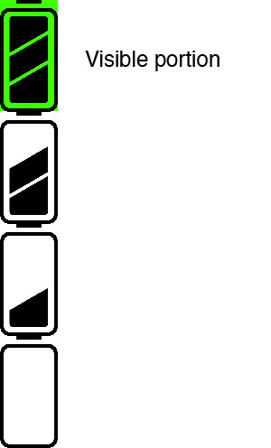

If we were to move the background image up, or in a negative measurement along the y axis, we could position it to see a different part of the background image. Since all four images are the same height, we can move the background image in a negative value along the y axis equal to the element's height to see the second image in our sprite sheet.

.moderate { /* Push the image up an amount equal to the height of each icon */ background-position: 0 -124px; }

This will allow the "moderate" class to reposition the background so that the second image in the sprite sheet is visible. We can do the same for the "low" and "empty" classes.

.low { /* Push it up another 124px */ background-position: 0 -248px; } .empty { /* -372px works as well, but because all icons are the same height you can use percentages */ background-position: 0 100%; }

Notice how we didn't use a pixel value for the "empty" class. This is to illustrate that we can use other measurements besides pixels to reposition our background image. Percentages could easily be used in place of pixel measurements in this case because each image is the same height.

And now we have a single sprite sheet rather than multiple images for our battery indicator! You can use the same technique for the x axis as well, allowing you to put images in your sprite sheet in both a horizontal and vertical orientation.